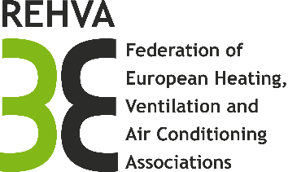

Active Task Forces in 2019

In 2019 the TRC welcomes new topics and proposals as many Task Forces are in final stage. Well-defined activities with outcomes useful for practitioners have a priority. The TRC chair and co-chairs are expected to be active in the work of selected Task Forces. A non-exhaustive list of 2019 topics includes:
- Smart Buildings (Task Force and Smart Readiness Indicator advocacy group)
- EU level harmonization of EPCs and EVCS (Collaboration with ALDREN and U-CERT projects)
- BIM in HVAC sector (collaboration with ProdBIM and BIM-SPEED project, CEN TC442)
- Focus on specific technologies such as hybridGEOTABS system design (collaboration with hybridGEOTABS project), air curtains (in collaboration with Eurovent), technical systems for greenhouses
- New proposals submitted by TRC members and PMC

Active Task Forces in 2019 (indicative list)

Title | Chair(s) | Outcome | Date of publication
REHVA-ISHRAE Building Commissioning Guidelines | Ole Teisen | Guidebook no.27 | 2019
MedZEB Part I | Ahmet Arisoy | Guidebook no.28 | 2019
Quality Management for Buildings | Ole Teisen, Stefan Plesser | Guidebook no.29 | 2019
Hygiene in air-conditioning systems (GB 9 update) | Frank Jansen | Guidebook no.9  revised edition | 2019
Hygiene in drinking-water supply systems | Thomas Wollstein, Christian Schauer | Guidebook | 2019
Air filtration in HVAC systems (GB 11 update) | Livio Mazzarella | Guidebook | 2019
REHVA -ASHRE joint GB on NZEB Hospitals | Wim Maassen | Guidebook | 2019 / TBD
IEQ in nZEB schools (REHVA-ISHRAE) | Livio Mazzarella | Guidebook | 2020
Smart Buildings | Ivo Martinac | Guidebook | 2020
Design guidelines for HybridGEOTABS buildings | TDB | Guidebook | 2020
Office buildings’ EPC common scale | Martin Thalfeldt, Jarek Kurnitski | Guidebook | 2021
MedZEB Part II | Ahmet Arisoy | Guidebook | TBD

